LAB WORKSHEET No. 1.1

Student Name:-ADITYA RAJ UID: 21BCS8948
Branch: Computer Science & Engineering Section/Group:703 A
Semester: 3rd Date of Performance:20/08/2022
Subject Name: DBMS Subject Code : 21CSH-214

Aim:
Create a table called Employee with the following structure.
Name Type
Empno Number
Ename Varchar2(10)
Job Varchar2(10)
Mgr Number
Sal Number
a. Add a column commission with domain to the Employee table.
b. Insert any five records into the table.
c. Update the column details of job
d. Rename the column of Employ table using alter command.
e. Delete the employee whose Empno is 105

Code:

create table Employee(Empno Number,Ename Varchar(10),Job Varchar(10),Mrg Number,Sal Number);

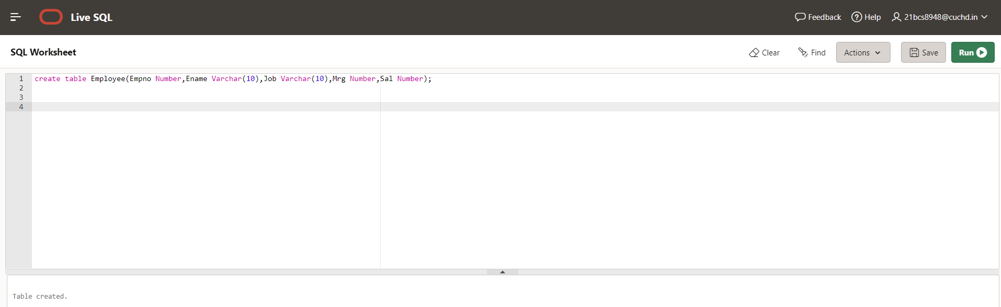

desc Employee;

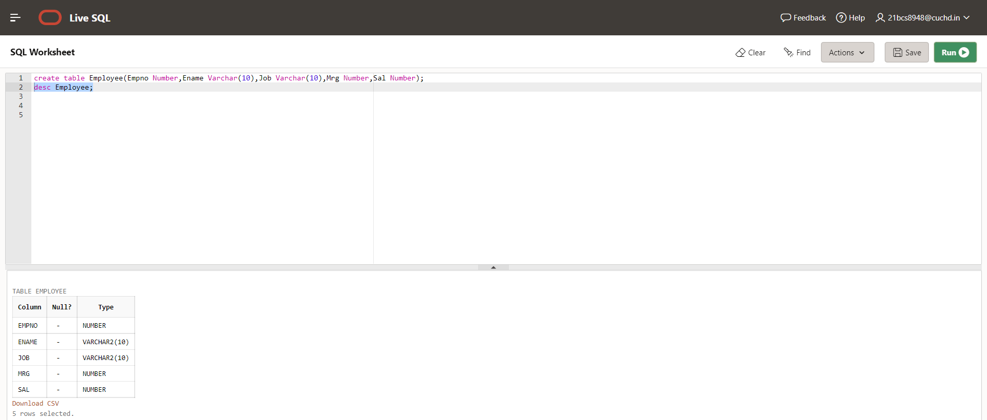

a. Add a column commission with domain to the Employee table.

- alter table Employee add commission Number;

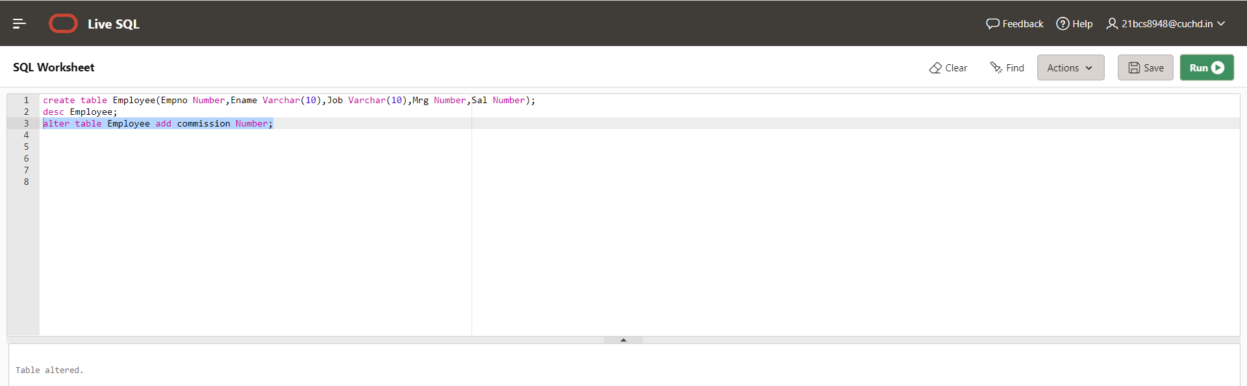

Desc Employee;

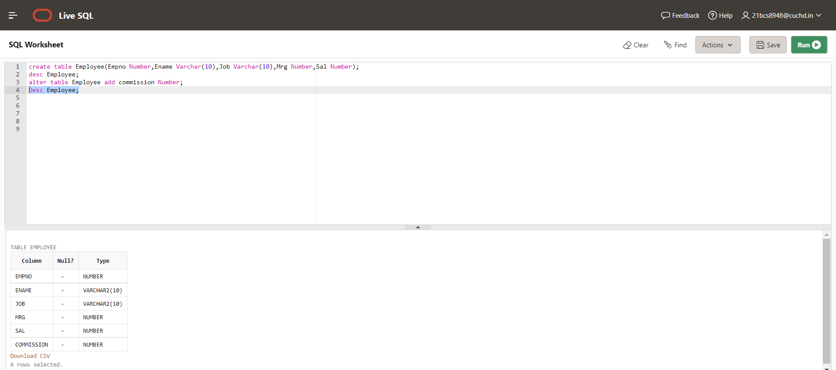

b. Insert five values into the table.

- insert into Employee(Empno,Ename,Job,Mrg,Sal,commission) values(101,'ADITYA','Professor',5402,100000,1000);

-insert into Employee(Empno,Ename,Job,Mrg,Sal,Commission) values(102,'SURAJ','Engineer',5000,120000,1500);

-insert into Employee(Empno,Ename,Job,Mrg,Sal,Commission) values(103,'PRATIK','Professor',5407,110000,2000);

-insert into Employee(Empno,Ename,Job,Mrg,Sal,Commission) values(104,'HARSH','IAS',5445,105000,10000);

-insert into Employee(Empno,Ename,Job,Mrg,Sal,Commission) values(105,'SONU','HOD',5405,110000,1000);

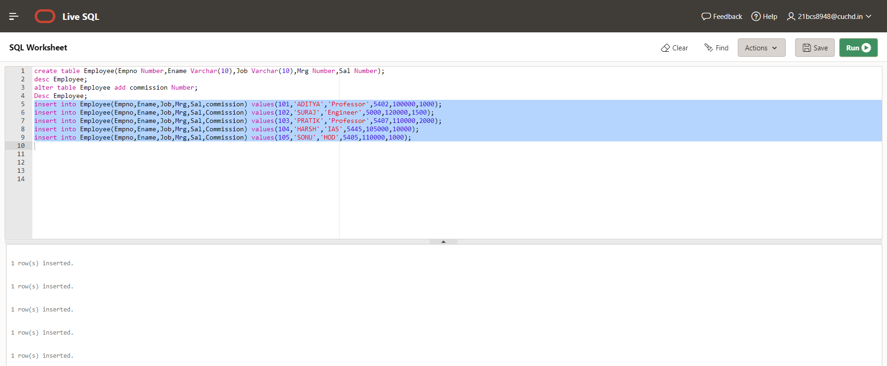

-

select * from Employee;

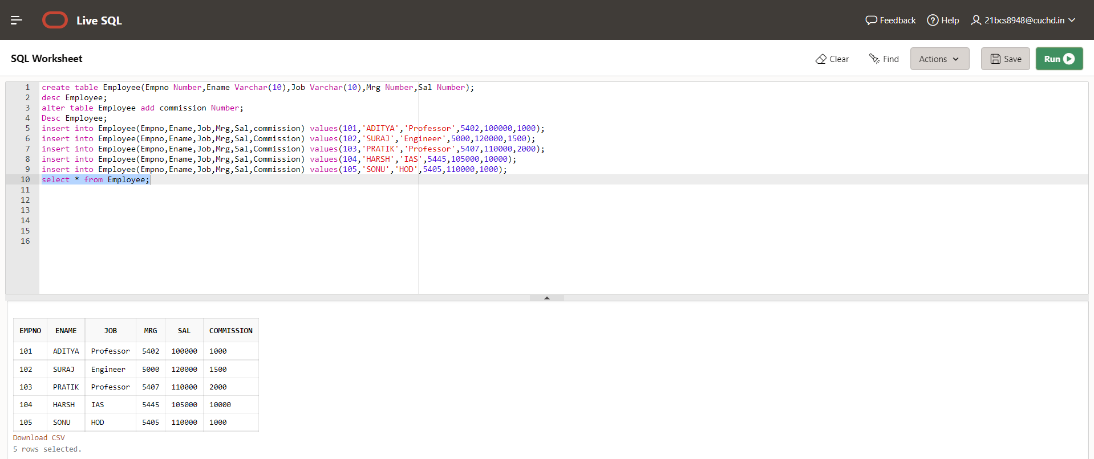

c. Update the column details of job

update Employee set job = 'IAS' where job = 'Professor';

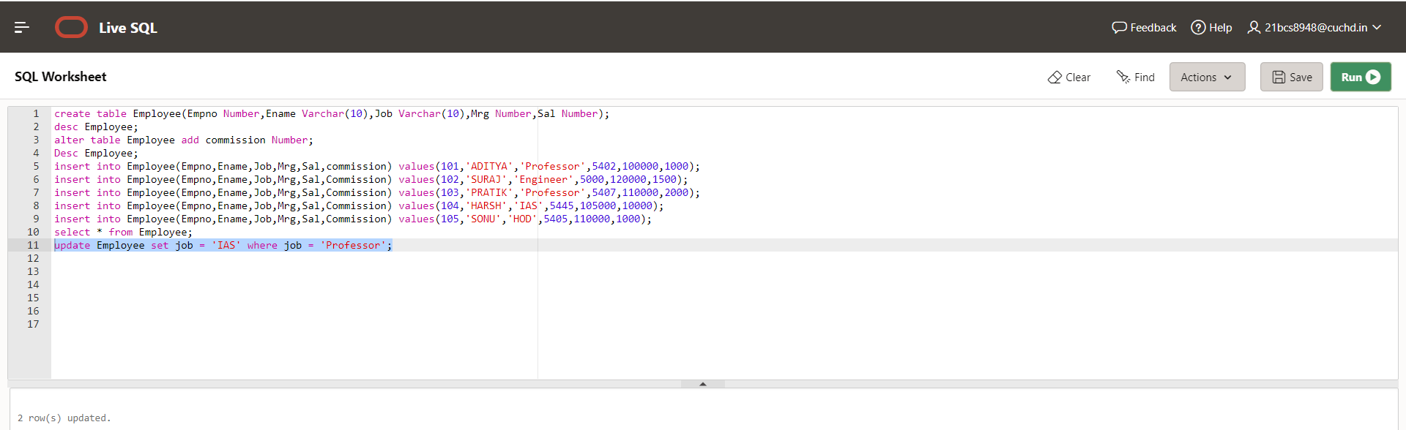

Select * from Employee;

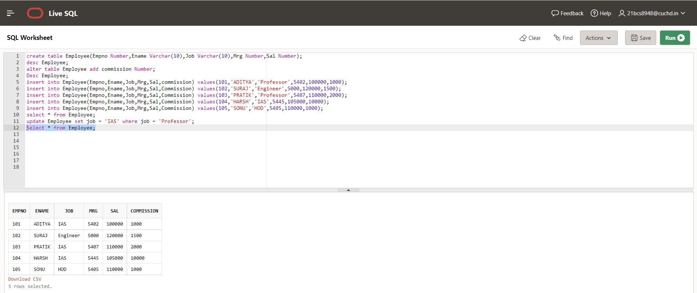

d. Rename the column of Employ table using alter command.
- alter table Employee Rename Column Commission to Comm;

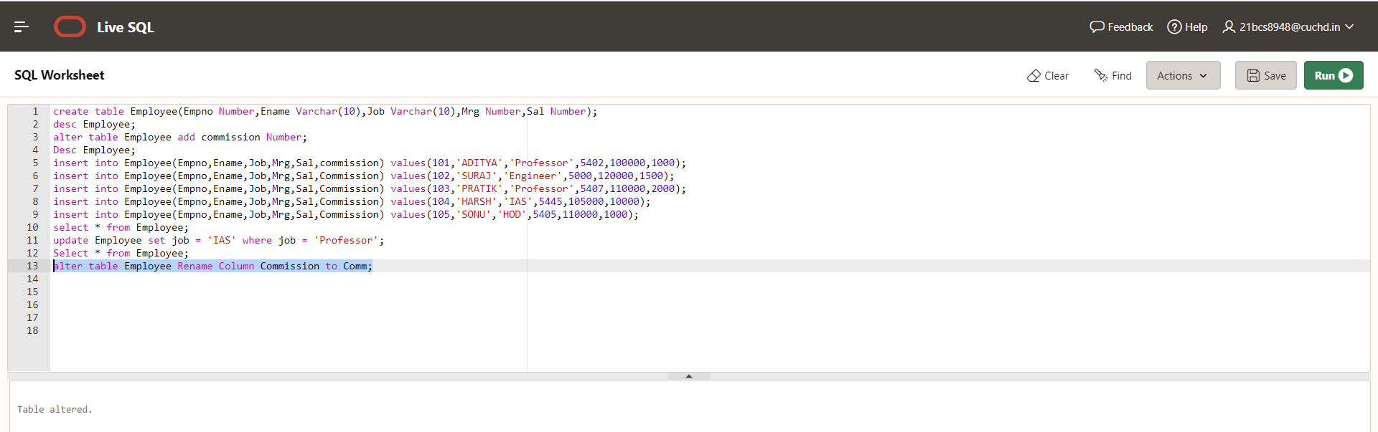

Select * from Employee;
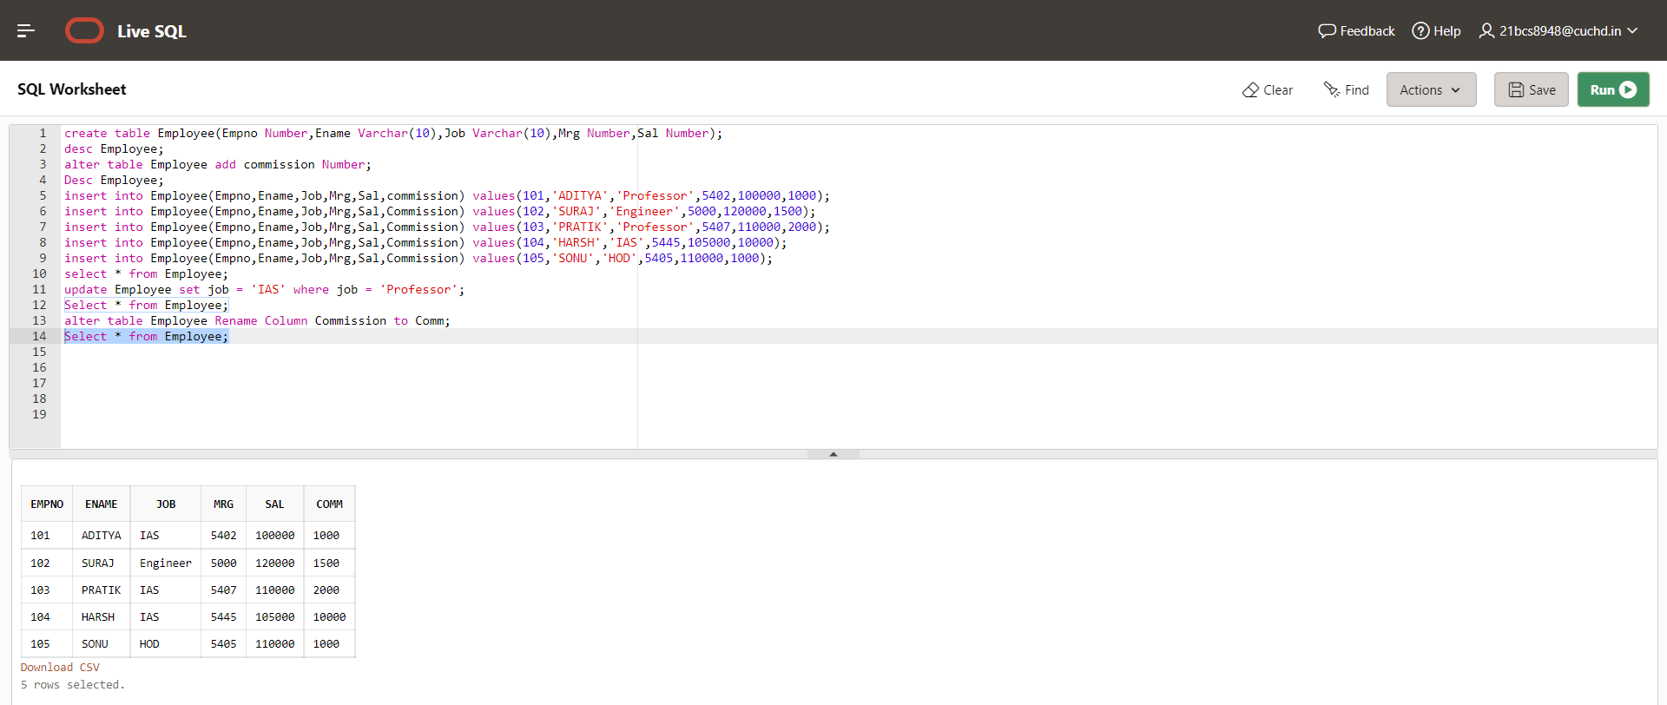

e. Delete the employee whose Empno is 105
- delete from Employee where Empno=105;
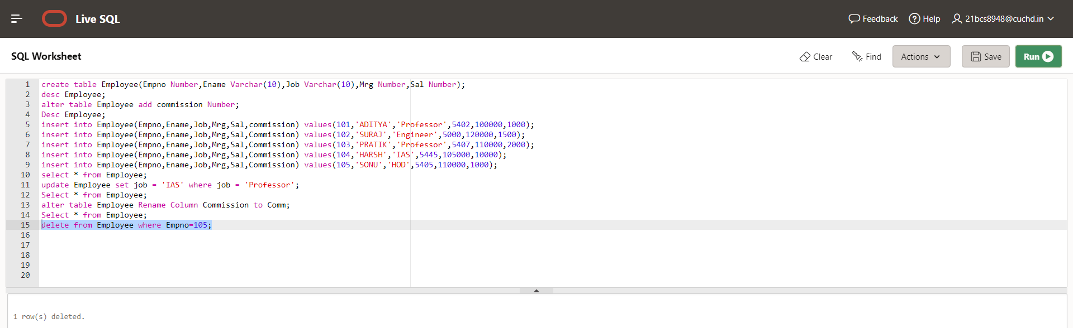

Select * from Employee;

